## **Objectives**

* Explain various ways of conditional rendering
* Explain how to render multiple components
* Define list component
* Explain about keys in React applications
* Explain how to extract components with keys
* Explain React Map, map() function

In this hands-on lab, you will learn how to:

* Implement conditional rendering in React applications

## **Prerequisites**

The following is required to complete this hands-on lab:

* Node.js
* NPM
* Visual Studio Code

## **Notes**

Estimated time to complete this lab: **60 minutes.**

Create a React App named “bloggerapp” in with 3 components.

1. Book Details
2. Blog Details
3. Course Details

Implement this with as many ways possible of Conditional Rendering.

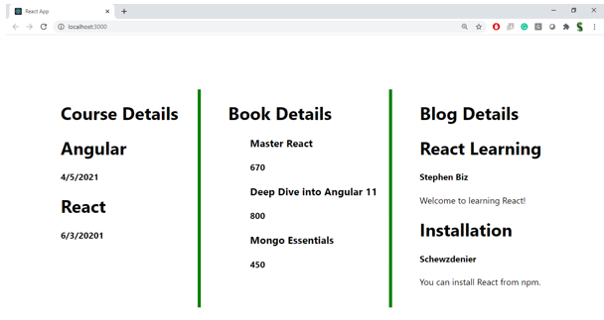

**Hint:**

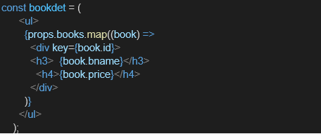

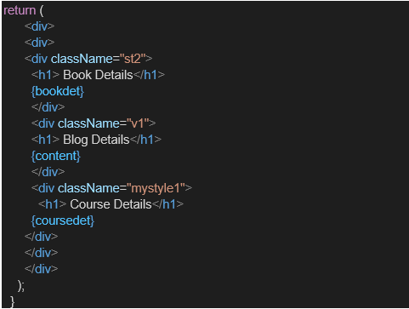

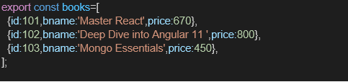

**Solution :**

**Step 1: Set Up the App**

In your terminal:

npx create-react-app bloggerapp

cd bloggerapp

**Folder Structure**

Inside src, create a components folder:

src/

components/

BookDetails.js

BlogDetails.js

CourseDetails.js

BookDetails.js

import React from 'react';

function BookDetails() {

return <div><h2>📚 Book Details</h2><p>React, Redux, and TypeScript for Professionals</p></div>;

}

export default BookDetails;

**BlogDetails.js**

import React from 'react';

function BlogDetails() {

return <div><h2>📝 Blog Details</h2><p>Exploring Hooks and Functional Components in React</p></div>;

}

export default BlogDetails;

CourseDetails.js

import React from 'react';

function CourseDetails() {

return <div><h2>🎓 Course Details</h2><p>Full Stack Web Development Bootcamp</p></div>;

}

export default CourseDetails;

**Conditional Rendering in App.js**

Open and edit App.js:

import React, { useState } from 'react';

import './App.css';

import BookDetails from './components/BookDetails';

import BlogDetails from './components/BlogDetails';

import CourseDetails from './components/CourseDetails';

function App() {

const [view, setView] = useState('book'); // initial component: 'book'

// 1️⃣ Using if-else

let content;

if (view === 'book') {

content = <BookDetails />;

} else if (view === 'blog') {

content = <BlogDetails />;

} else {

content = <CourseDetails />;

}

return (

<div className="App">

<h1>📖 Blogger App</h1>

<div>

<button onClick={() => setView('book')}>Book</button>

<button onClick={() => setView('blog')}>Blog</button>

<button onClick={() => setView('course')}>Course</button>

</div>

<hr />

{/* 1. Rendering using if-else stored in variable */}

{content}

<hr />

{/* 2️⃣ Ternary operator */}

{view === 'book' ? (

<BookDetails />

) : view === 'blog' ? (

<BlogDetails />

) : (

<CourseDetails />

)}

<hr />

{/* 3️⃣ Logical && rendering */}

{view === 'book' && <BookDetails />}

{view === 'blog' && <BlogDetails />}

{view === 'course' && <CourseDetails />}

<hr />

{/* 4️⃣ Switch-case rendering inside function */}

{renderWithSwitch(view)}

</div>

);

}

// 4. Conditional rendering using switch

function renderWithSwitch(view) {

switch (view) {

case 'book':

return <BookDetails />;

case 'blog':

return <BlogDetails />;

case 'course':

return <CourseDetails />;

default:

return <h4>Select a view above</h4>;

}

}

export default App;